Create a Simple Pipeline (Amazon S3 Bucket) – Refer below for more Tutorials

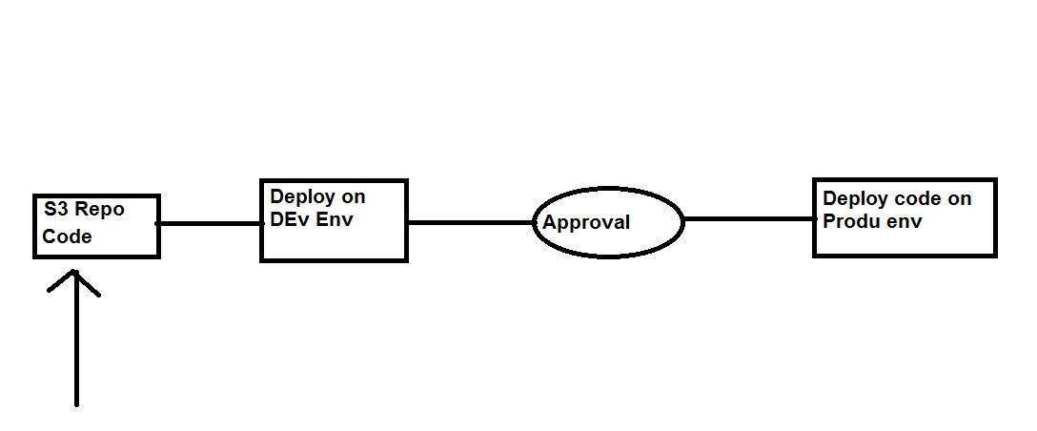

Step 1: Upload the Code to be deployed on the Dev/Prod Env in to S3 Bucket from the below github
https://github.com/awslabs/aws-codepipeline-s3-aws-codedeploy_linux

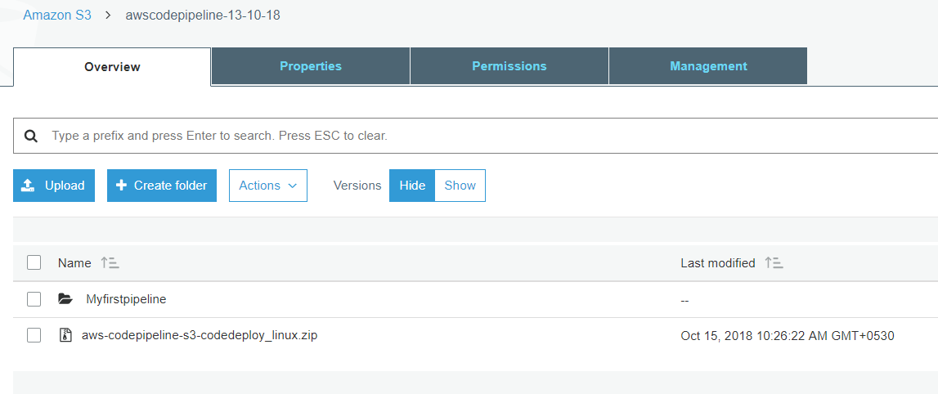

Step 2: Create 2 EC2 instance with CodeDeploy Agent and the required IAM policy to access S3 bucket.
Lab-Setups -- CodeDeploy
- Create 2 IAM Policies ,
  - Provide – S3 – get and list Permission for the EC2 instance. -- EC2-codedeploy
  - Provide – Full Ec2 Access for the CodeDeploy -- CodeDeploy
Create Roles , eg: -- EC2-codedeploy and CodeDeploy
- Create 2 Ec2 instance with “EC2-codedeploy” Roles attached to it
- Install the Codedeploy agent on the EC2 instance.
- Create an CodeDeploy deployment code.
- Create an ‘New Deploy” and point to the S3 location of the Sample-linux.zip file

Step 1. Policy Creation
- IAM Policy -- EC2-codedeploy for EC2 to access S3
{
"Version": "2012-10-17",
"Statement": [
{
"Action": [
"s3:Get*",
"s3:List*"
],
"Effect": "Allow",
"Resource": "*"
}
]
}
- IAM Role for EC2-codedeploy
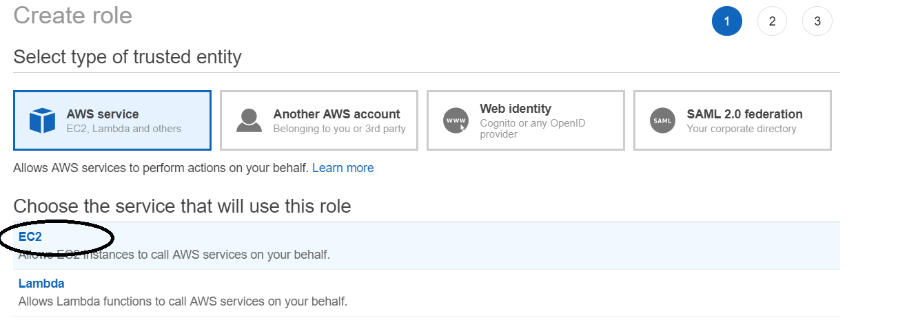
Then attach the policy “EC2-codedeploy
- IAM Policy -- Codedeploy to access EC2 instance.
Eg:-- “Codedeploy”
{
"Version": "2012-10-17",
"Statement": [
{
"Sid": "VisualEditor0",
"Effect": "Allow",
"Action": [
"ec2:*"
],
"Resource": "*"
}
]
}
- IAM Role for “CodeDeploy”

Then attach the above Codedeploy Policy to this IAM role

Add the below trust relationship on the CodeDeploy Role
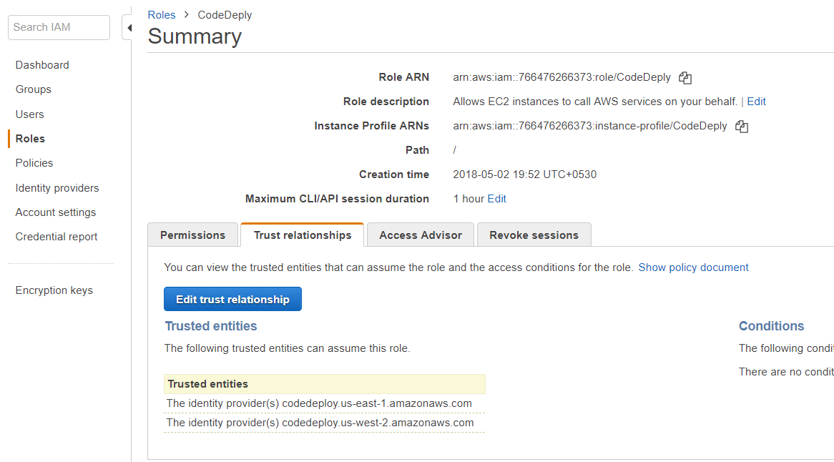
Click on “Edit trust relationship”
{
"Version": "2012-10-17",
"Statement": [
{
"Sid": "",
"Effect": "Allow",
"Principal": {
"Service": [
"codedeploy.us-east-1.amazonaws.com",
"codedeploy.us-west-2.amazonaws.com"
]
},
"Action": "sts:AssumeRole"
}
]
}

Step 2. Create EC2 instance
Create 2 Instance with the “EC2-codedeploy” Role

Step 3: Install the Codedeploy agent on the EC2 instance.
sudo yum update
sudo yum install ruby
sudo yum install wget
cd /home/ec2-user
wget https:// aws-codedeploy-us-east-1.s3.amazonaws.com/latest/install
chmod +x ./install
sudo ./install auto
service codedeploy-agent start

Resource Kit Bucket Names by Region
This table lists the names of bucket-name replacements required for some procedures in the guide. These are the names of the Amazon S3 buckets that contain the AWS CodeDeploy Resource Kit files.
Region name | bucket-name replacement | Region identifier
US East (Ohio) | aws-codedeploy-us-east-2 | us-east-2
US East (N. Virginia) | aws-codedeploy-us-east-1 | us-east-1
US West (N. California) | aws-codedeploy-us-west-1 | us-west-1
US West (Oregon) | aws-codedeploy-us-west-2 | us-west-2
Canada (Central) | aws-codedeploy-ca-central-1 | ca-central-1
EU (Ireland) | aws-codedeploy-eu-west-1 | eu-west-1
EU (London) | aws-codedeploy-eu-west-2 | eu-west-2
EU (Paris) | aws-codedeploy-eu-west-3 | eu-west-3
EU (Frankfurt) | aws-codedeploy-eu-central-1 | eu-central-1
Asia Pacific (Tokyo) | aws-codedeploy-ap-northeast-1 | ap-northeast-1
Asia Pacific (Seoul) | aws-codedeploy-ap-northeast-2 | ap-northeast-2
Asia Pacific (Singapore) | aws-codedeploy-ap-southeast-1 | ap-southeast-1
Asia Pacific (Sydney) | aws-codedeploy-ap-southeast-2 | ap-southeast-2
Asia Pacific (Mumbai) | aws-codedeploy-ap-south-1 | ap-south-1
South America (São Paulo) | aws-codedeploy-sa-east-1 | sa-east-1

Step 4: Create an CodeDeploy deployment code for “Dev Env”

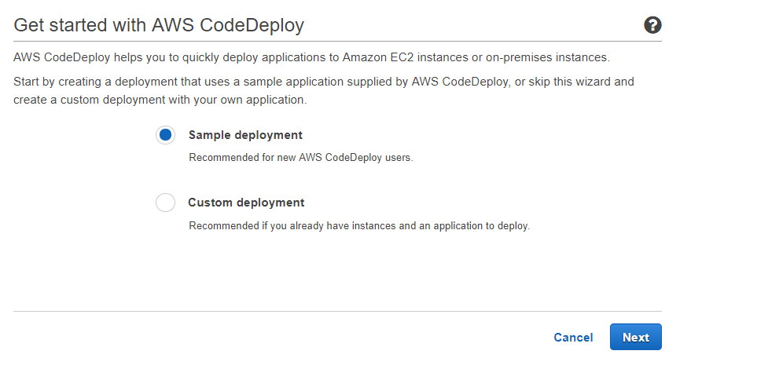
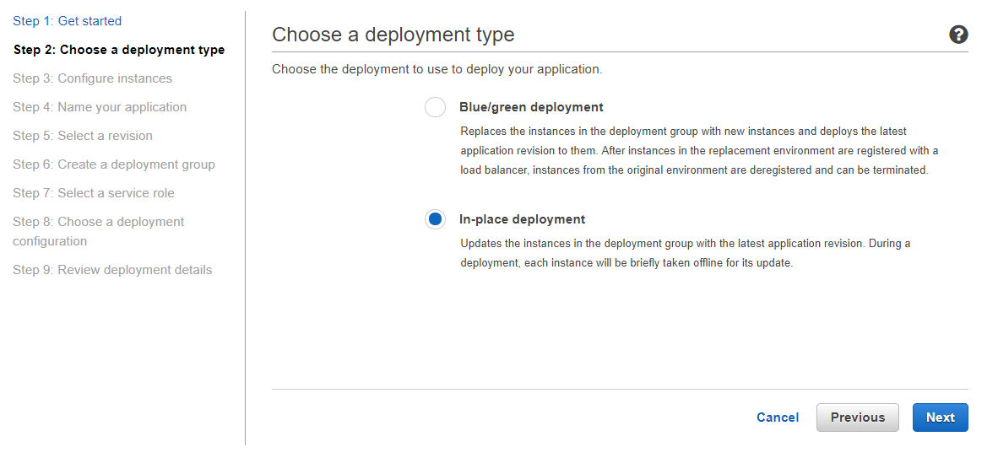

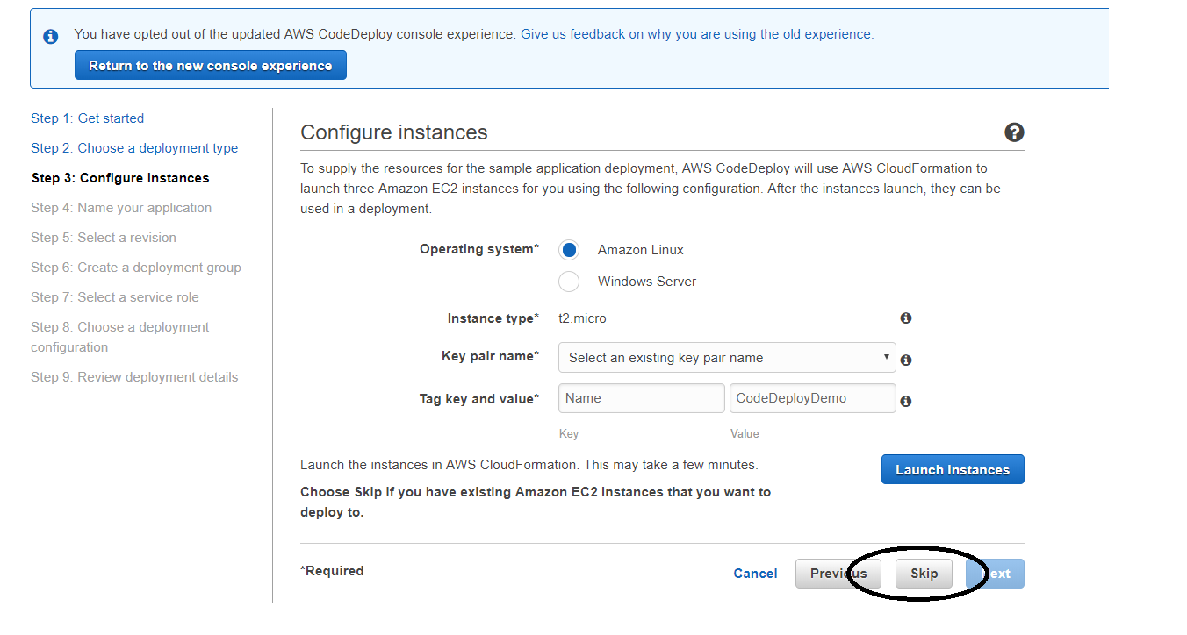
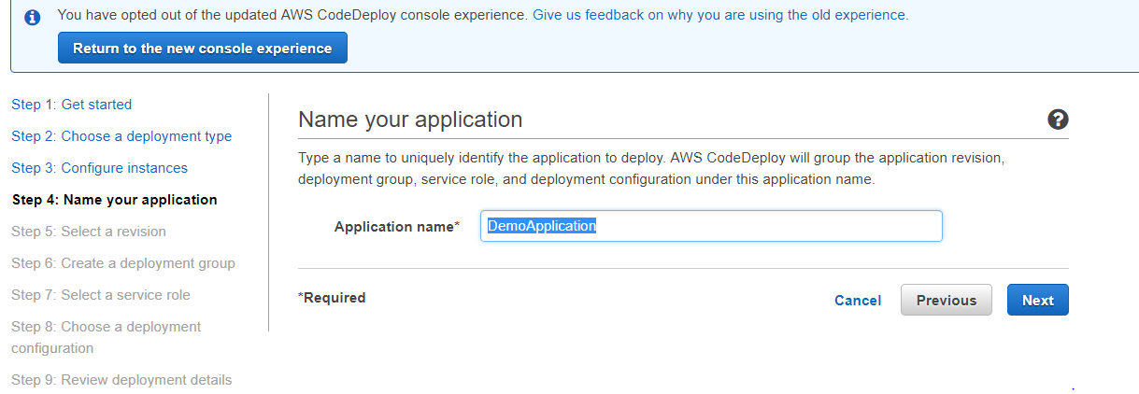

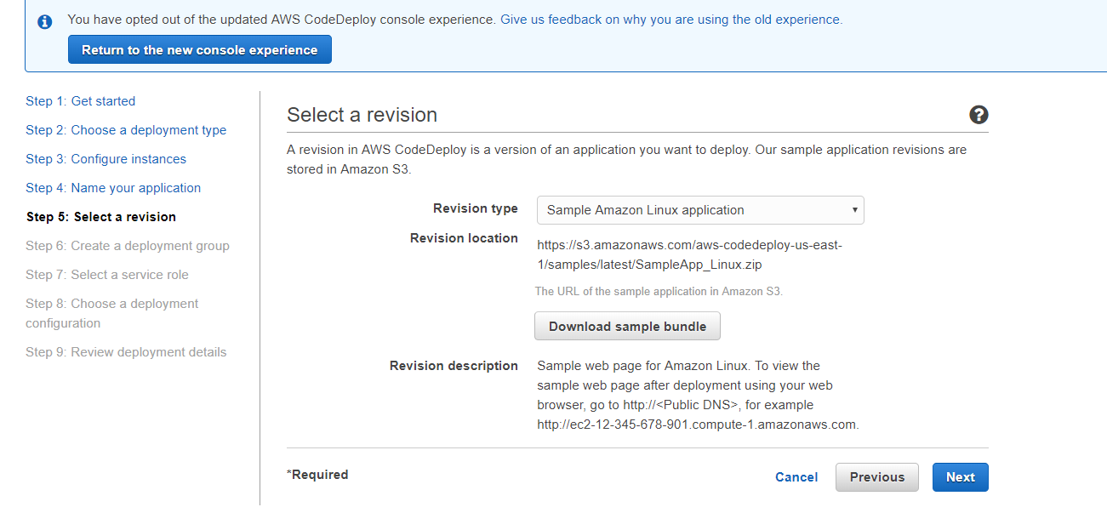

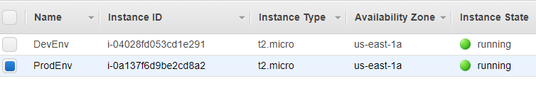
Name the EC2 Instance with above Names
Also make sure “EC2-Codedeploy” IAM Role is selected.
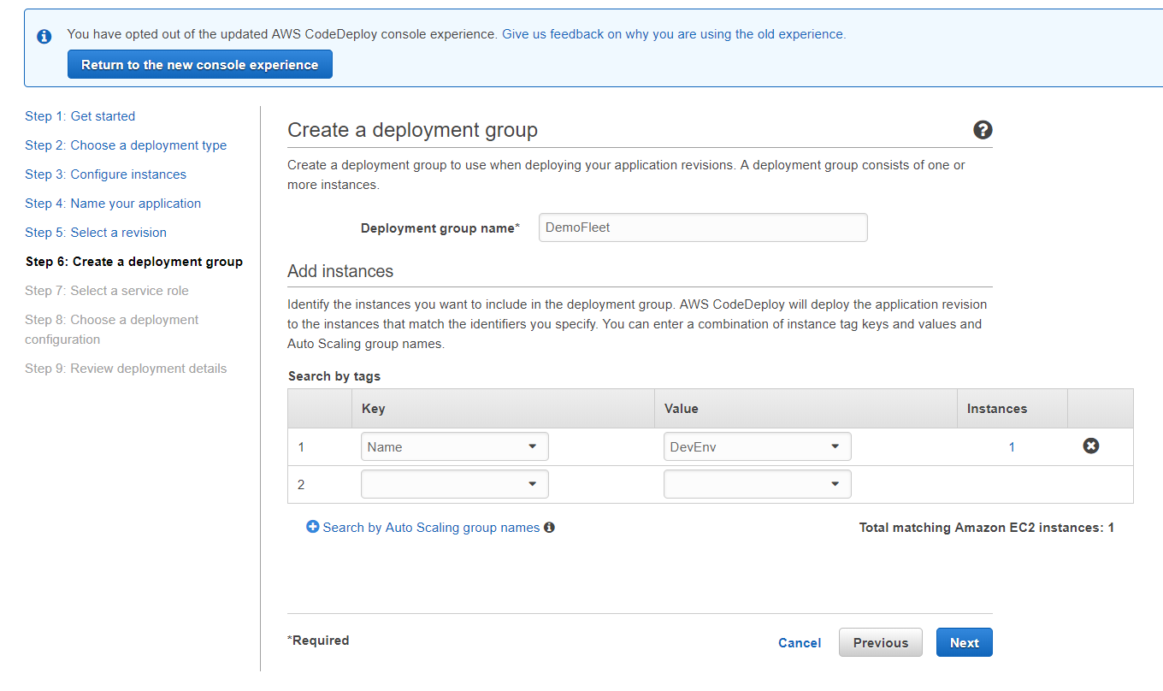

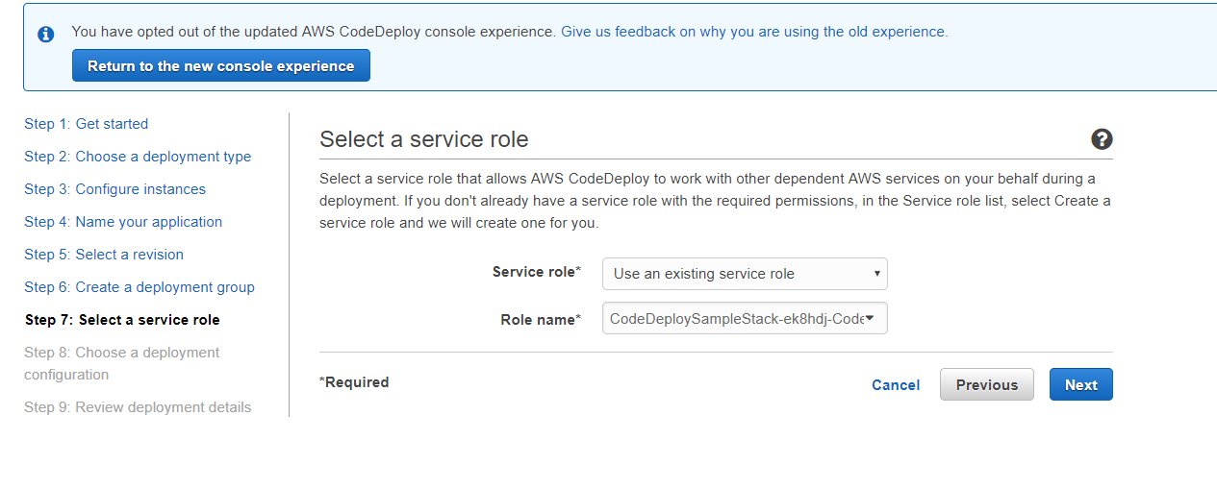
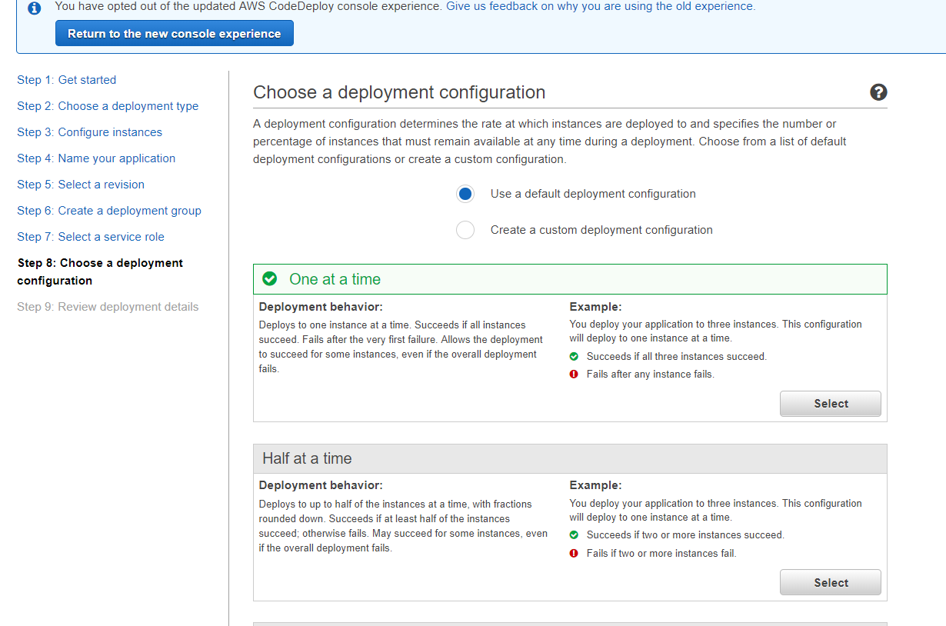
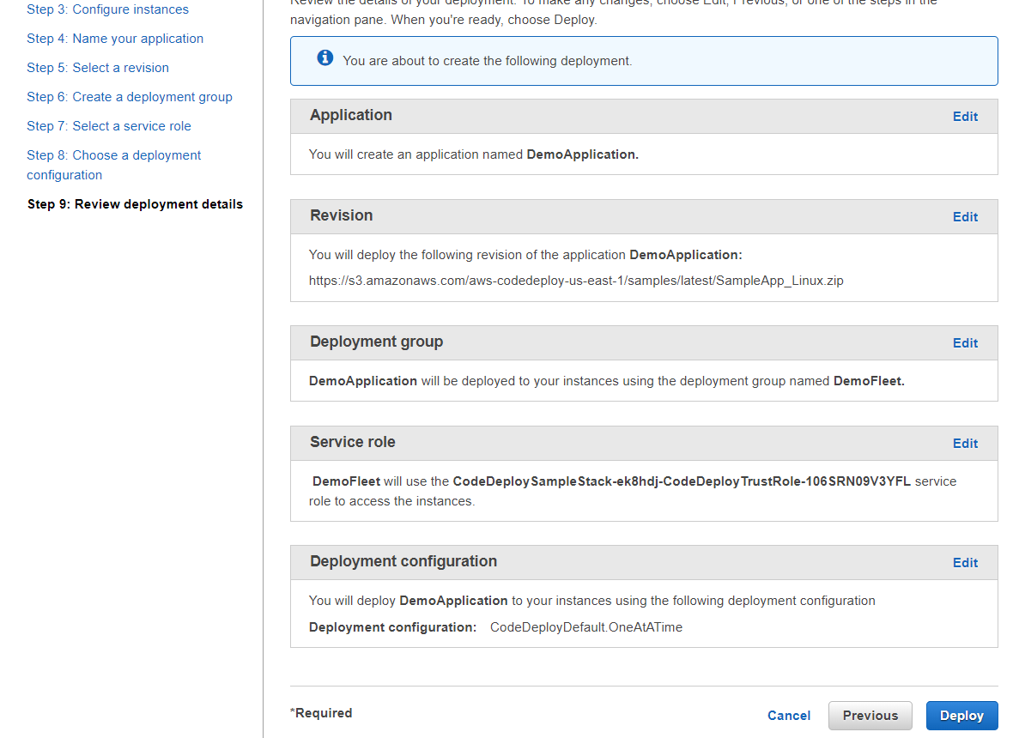

Successfully Application Deployment Group has been created.
Now on the codeploy “New Revision Deploy” on the Dev Env with
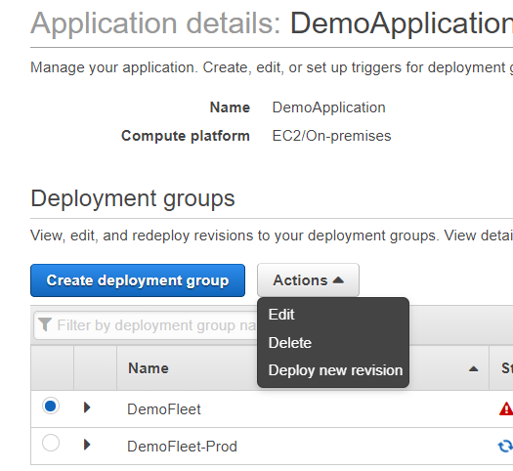
s3://aws-codedeploy-us-east-1/samples/latest/SampleApp_Linux.zip
Note: -- THIS IS NOT THE SAME AS YOU HVE UPLOADED INTO YOUR S3 Bucket.
This sample app is an base sample app.

Step 5: Create an CodeDeploy deployment code for “Prod Env”
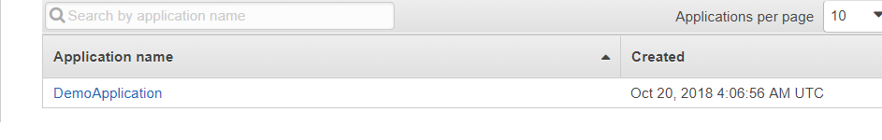

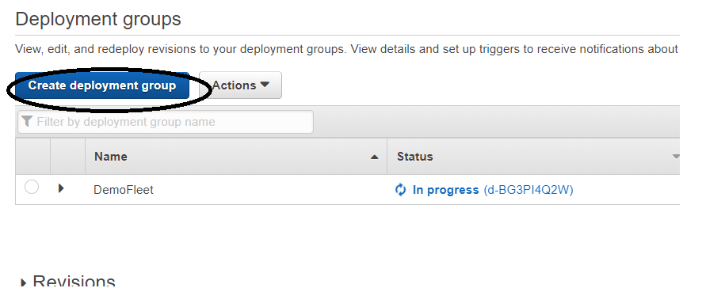

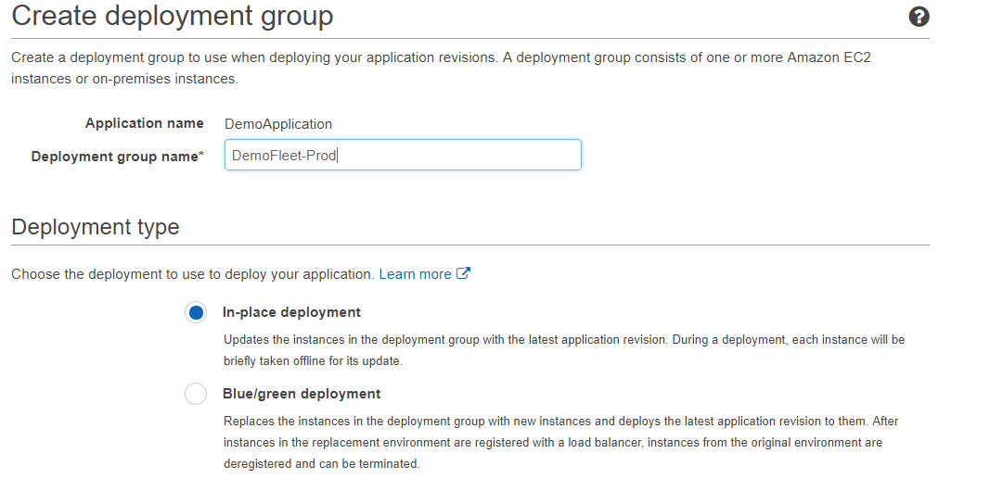

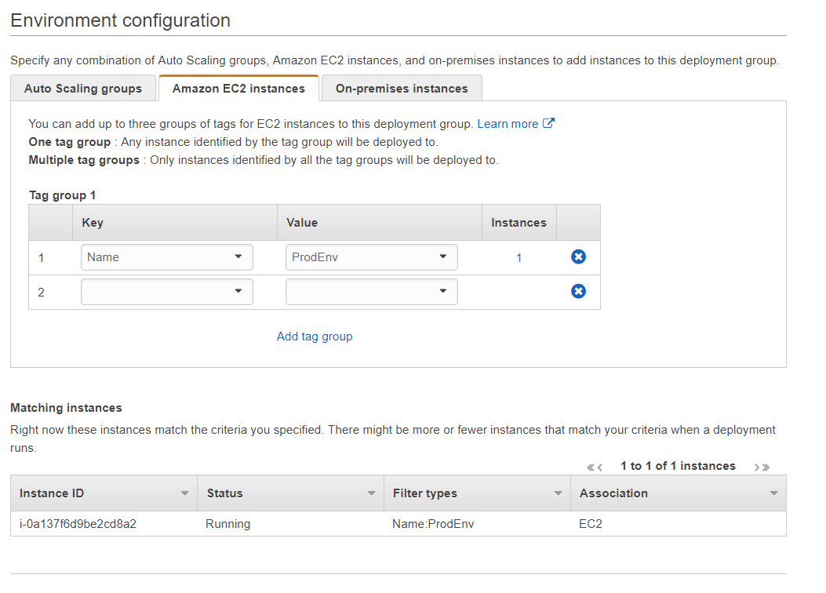

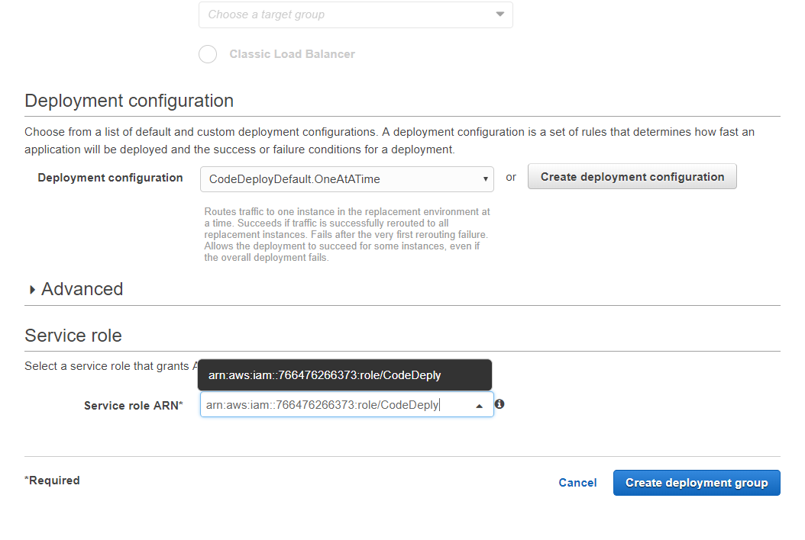

Create an “New Deploy”


s3://aws-codedeploy-us-east-1/samples/latest/SampleApp_Linux.zip
Note: -- THIS IS NOT THE SAME AS YOU HVE UPLOADED INTO YOUR S3 Bucket.
This sample app is an base sample app.

Under Content option “ Overwrite the content”
The Above screen would take upto 5 min as there are 2 instance in this example.

